**USING ALMA ANAYTICS**

Use the following analytics report:

New Acquisitions - TARL API in

/shared/Community/Reports/Institutions/44WST

Copy this report to your own shared folder.

You will need to construct an API call. An outline of how to do this can be found here:

From (<https://developers.exlibrisgroup.com/blog/how-to-use-an-api-to-retrieve-an-alma-analytics-report/>)

Based on the documentation an example of the call broken into its four parts would be:

|  |  |  |  |
| --- | --- | --- | --- |
| domain | Additional analytics info | Report path/name | List limit and key |
| <https://api-eu.hosted.exlibrisgroup.com> | /almaws/v1/analytics/reports?path=%2F | path=%2Fshared%2FUniversity%20of%20Westminster%2FReports%2FContent%20and%20Digital%20Services%2FNew%20Acquisitions%20-%20TARL%20API | &limit=25&col_names=true&apikey=l**************************************** |

Which joined together would be:

[https://api-eu.hosted.exlibrisgroup.com/almaws/v1/analytics/reports?path=%2Fshared%2FUniversity%20of%20Westminster%2FReports%2FContent%20and%20Digital%20Services%2FNew%20Acquisitions%20-%20TARL%20API&limit=25&col_names=true&apikey=l7************************](https://api-eu.hosted.exlibrisgroup.com/almaws/v1/analytics/reports?path=%2Fshared%2FUniversity%20of%20Westminster%2FReports%2FContent%20and%20Digital%20Services%2FNew%20Acquisitions%20-%20TARL%20API&limit=25&col_names=true&apikey=l7************************)

Take path, and add to $alma_lookup in your user.config.php file

example

//Alma API call to analytics report

$alma_lookup = 'https://api-eu.hosted.exlibrisgroup.com/almaws/v1/analytics/reports?path=%2Fshared%2FUniversity%20of%20Westminster%2FReports%2FContent%20and%20Digital%20Services%2FNew%20Acquisitions%20-%20TARL%20API&limit=25&col_names=true&apikey=l*************************';

?>

The column values are as follows:

<Column0>0</Column0>

<Column1> full_name

<Column3> resource_type

<Column4> lcn

<Column5> publisher_name

<Column6> title

<Column7> web_addresses

<Column8> isbn

These will write to the relevant fields in a Talis Aspire Reading List record.

Please note, the report in the shared folder is for recent acquisitions. However, this report can be changed to produce a wide range of reports. The key thing to remember is the importance of retaining the same values in the same columns. If you wish to change column positions or values, it would require changes to the script. If you are uncertain of how to do this it is recommended you speak to the Talis Developer Community.

You can also add ‘importance’ values to your records. The ‘importance’ values for a record are unique to each institution.

To find the importance you wish to apply to the imported records do the following.

* Bring up a TARL record with a specific ‘importance’ applied.
* Right click and select ‘inspect’.
* Change the ‘importance’
* Then in ‘headers’ : ‘request payload’ the relevant identifier will be visible.

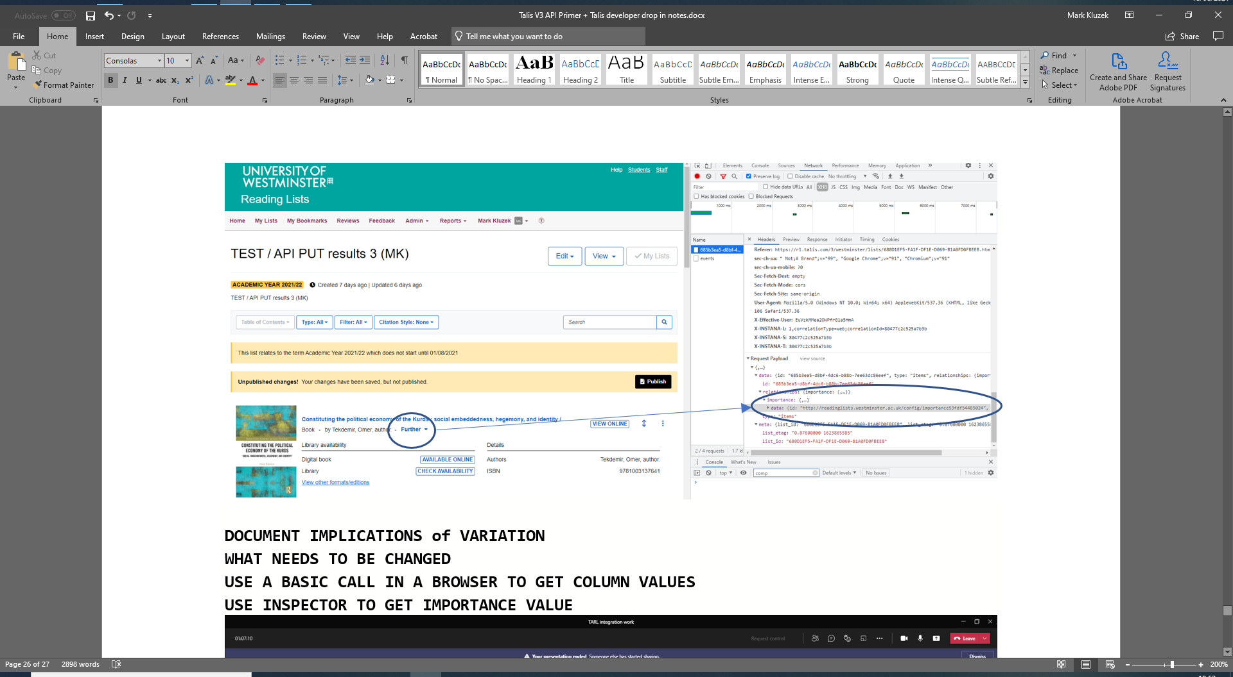

Copy the above "id", for example: "http://readinglists.westminster.ac.uk/config/importance53fdf54c4f1c0",

Add to **user.config.php**

$importanceID = ' http://readinglists.westminster.ac.uk/config/importance53fdf54c4f1c0';

**USING A TAB DELIMITED FILE (txt)**

Please structure your input file like so:

Author->Edition->Resource_type->LCN->Publisher_name->Title->Web_address->ISBN



ISBN RESOURCE TYPE RECORD ID TITLE

273731092 Book 997210320003711 The seven Cs of consulting : the definitive guide to the consulting process /

AUTHOR EDITION

"Cope, Mick, author." Third edition.

URL PUBLISHER

<https://ebookcentral.proquest.com/lib/westminster/detail.action?docID=6401406> Financial Times Prentice Hall

example

1137348127 Book 997211720103711 "Improvisation in drama, theatre and performance : history, practice, theory /" "Frost, Anthony, author." Third edition. <https://www.vlebooks.com/vleweb/product/openreader?id=WestminUni&isbn=9781137348128> Palgrave